Set 10

4. Dashboard
- Click New Dashboard.
- Drag the following sheets onto the dashboard:
  - Map Chart
  - Scatter Plot
  - Table
- Arrange them neatly.
- Title:
Geographic Data Dashboard

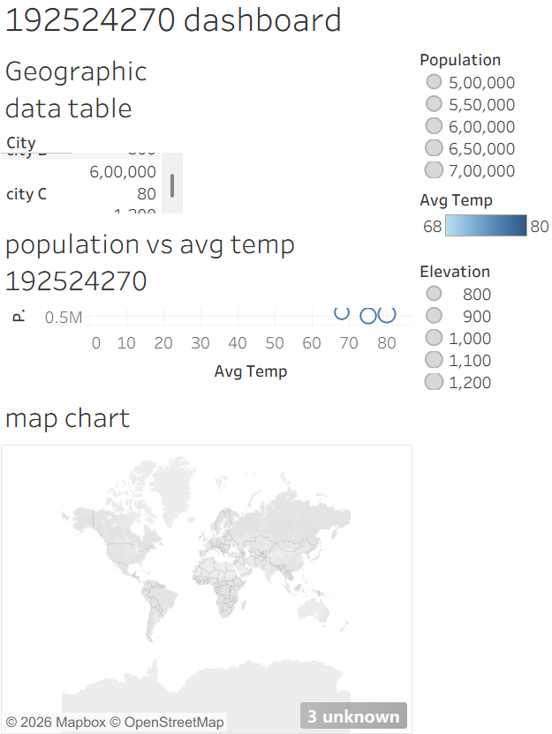

Steps
- Open Tableau and connect to your dataset.
- Open a New Worksheet.
- Right-click the City field → Geographic Role → City.
- Double-click City.
  - Tableau automatically creates a map.
- Drag Population to Size.
- Drag Avg. Temperature to Color.
- Drag City to Label.
- Rename the worksheet to City Map.

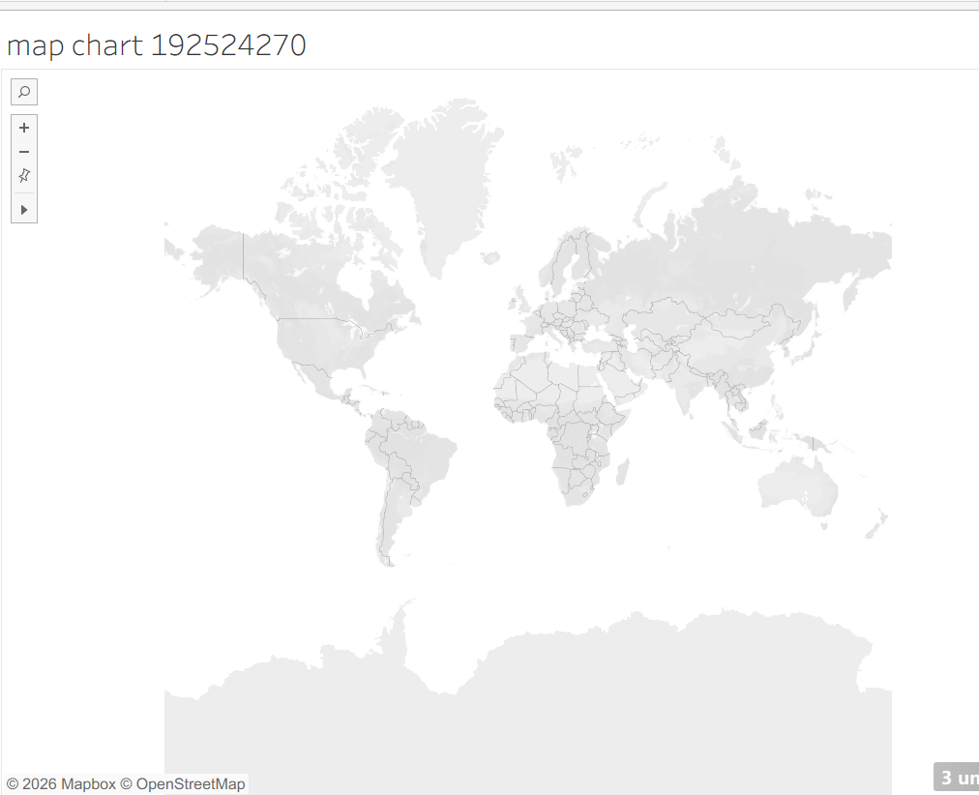

3. Table
- Open a new worksheet.
- Drag City → Rows.
- Drag Population, Avg. Temperature, and Elevation → Text.
- Title:
Geographic Data Table

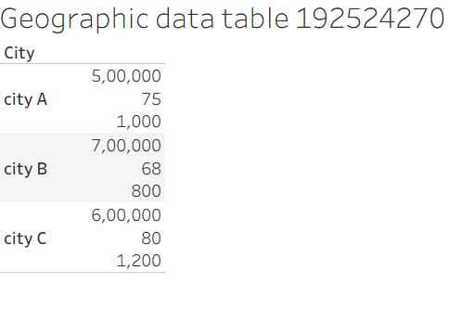
2. Scatter Plot
- Open a new worksheet.
- Drag Avg. Temperature → Columns.
- Drag Population → Rows.
- Drag City → Label.
- Drag Elevation → Size (optional).
- Title:
Population vs Average Temperature

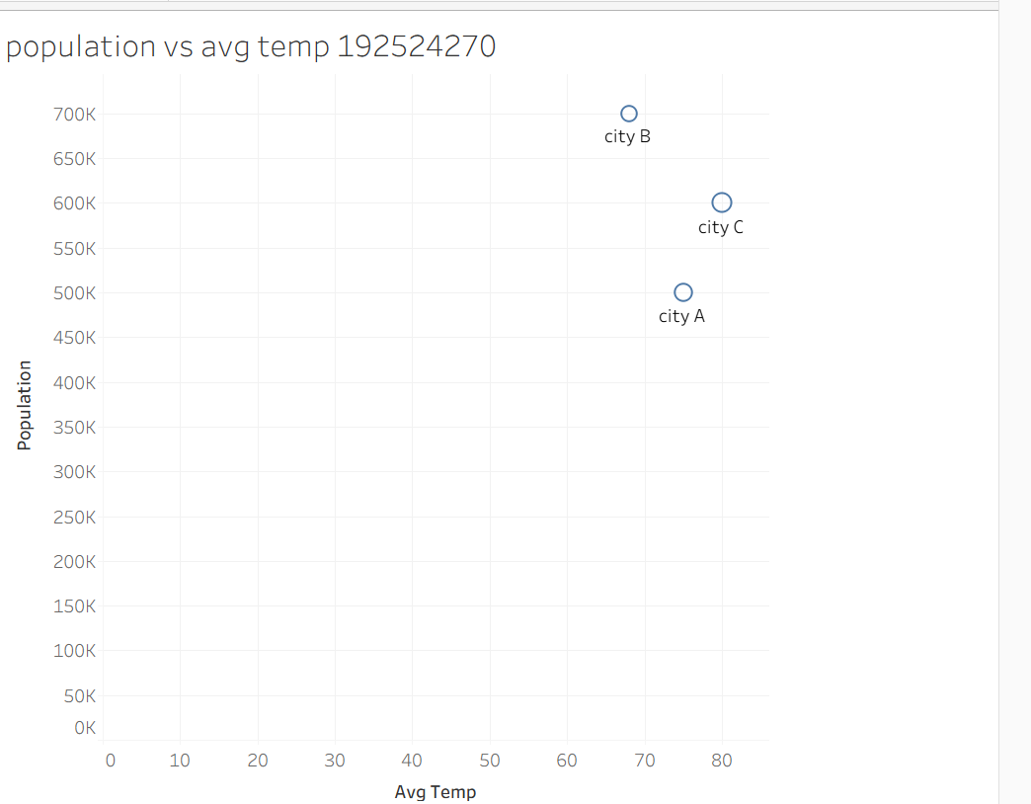

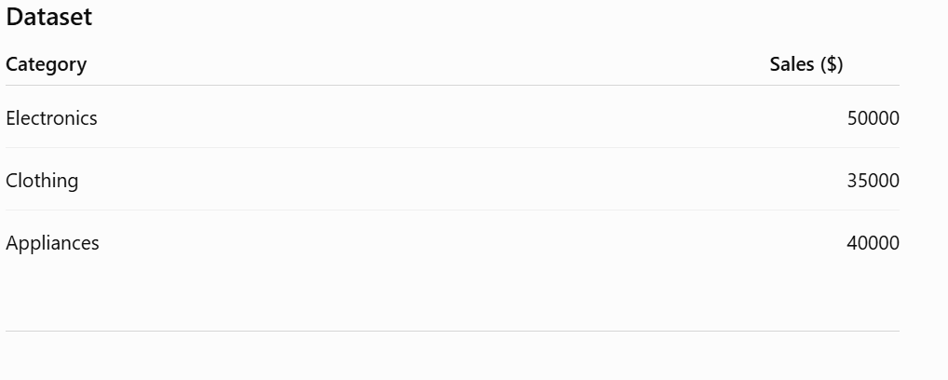
Set 9
1. Funnel Chart
Steps:
- Open Tableau.
- Connect to the dataset.
- Drag Category → Rows.
- Drag Sales → Columns.
- Click Show Me → Funnel Chart (or create using Bar chart and adjust size if Funnel is unavailable).
- Drag Sales → Label.
- Give the title:
"Sales Conversion Funnel by Product Category"
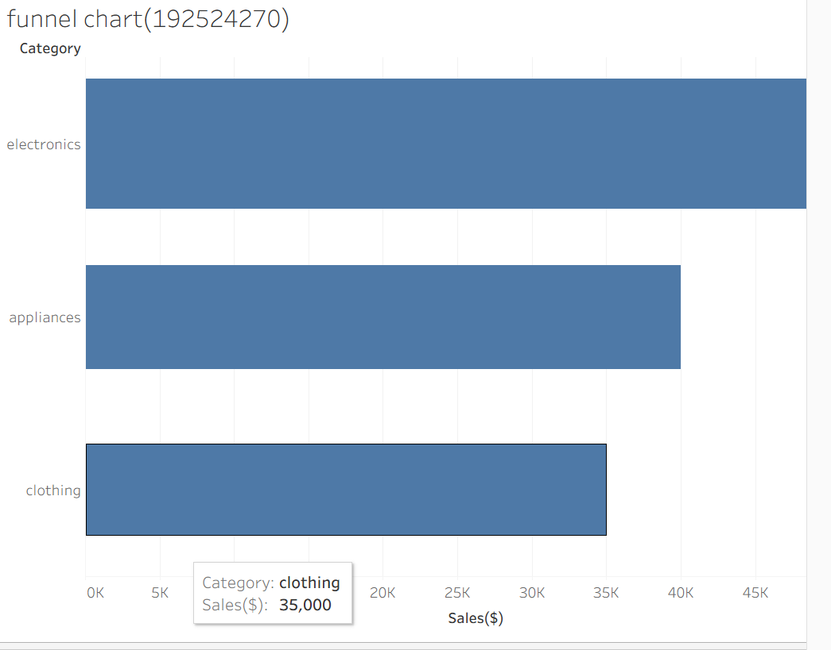
3. Dashboard
- Click New Dashboard.
- Drag the following sheets onto the dashboard:
  - Funnel Chart
  - Pie Chart
  - Sales Table
- Arrange them neatly.
- Dashboard title:
"Product Category Analysis Dashboard"

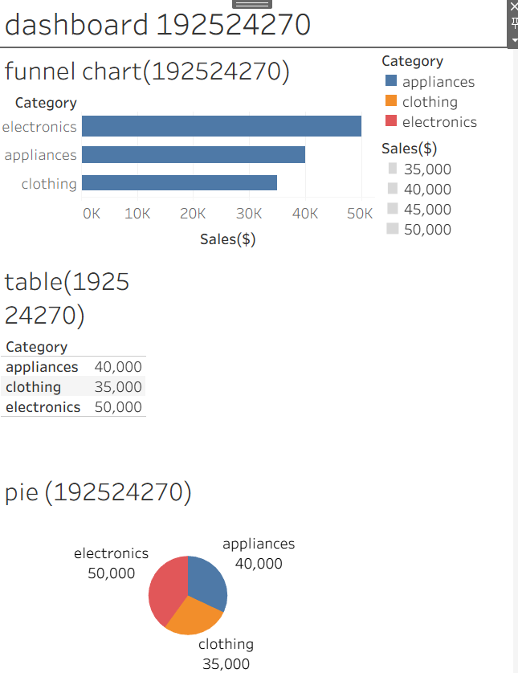
2. Table
- Create a new worksheet.
- Drag Category → Rows.
- Drag Sales → Text (Marks card).
- Rename the title:
"Product Category Sales Table"
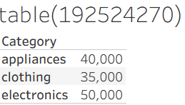
4. Pie Chart
- Create a new worksheet.
- Drag Category → Color.
- Drag Sales → Angle.
- Drag Category and Sales → Label.
- Change Marks to Pie.
- Title:
"Sales Distribution by Product Category"
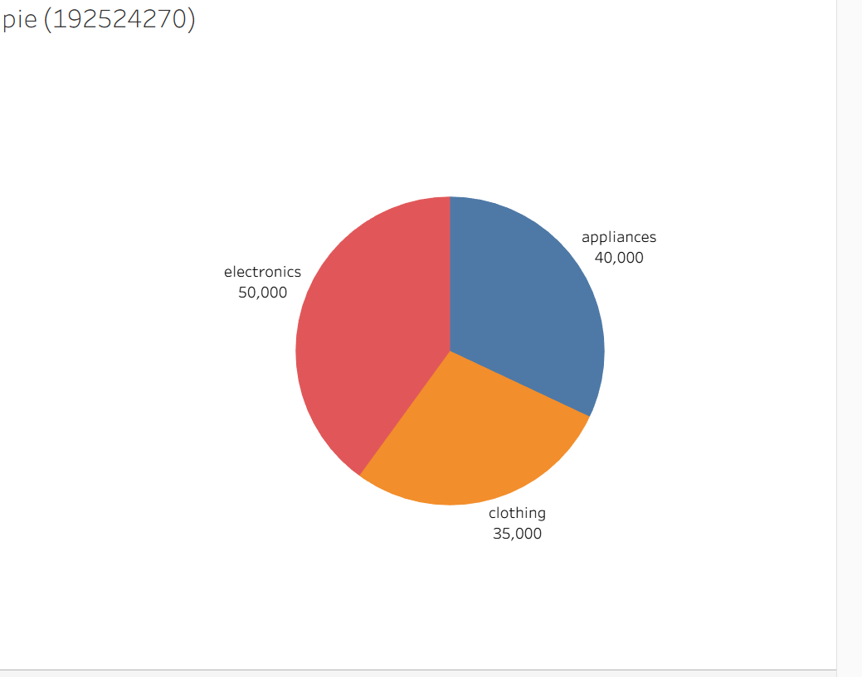

SET 8
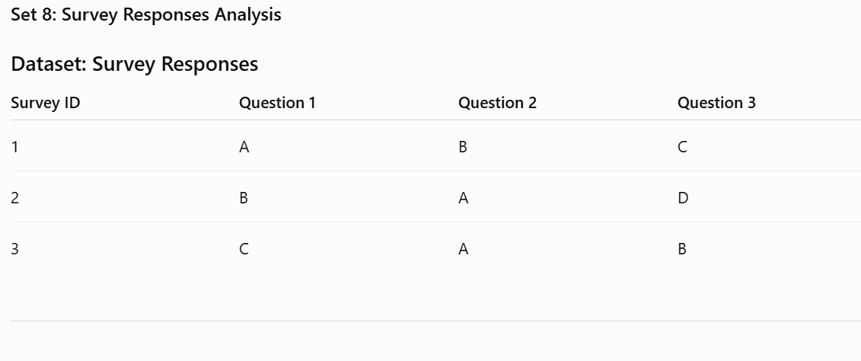
- Create a Grouped Bar Chart (Question 1)
- Open Tableau and connect to the Excel file.
- Drag Question 1 to Columns.
- Drag Number of Records to Rows.
- Set Marks to Bar.
- Drag Question 1 to Color.
- Add labels by clicking Label → Show Mark Labels.
- Give the title:
Distribution of Responses for Question 1
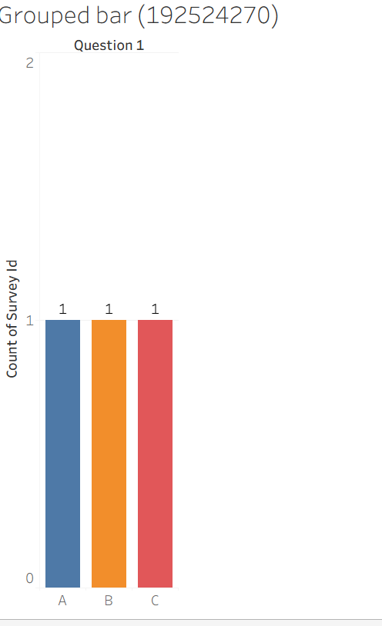
2. Create a Stacked Bar Chart
Tableau Steps
- Drag Measure Values to Rows.
- Drag Question (or Pivot Field Names after pivoting) to Columns.
- Drag Responses to Color.
- Ensure Analysis → Stack Marks → On.
- Add labels.
Chart Title:
Overall Distribution of Survey Responses
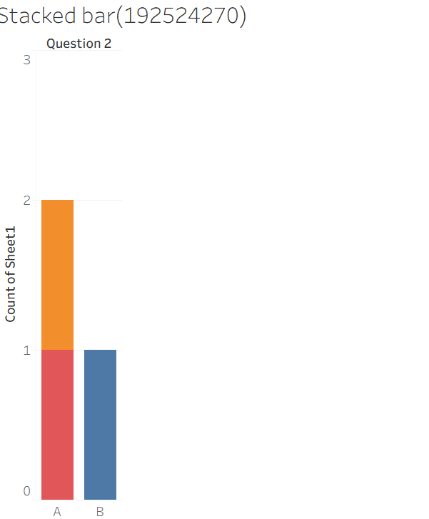

3. Create a Table
- Drag Survey ID to Rows.
- Drag Question 1, Question 2, and Question 3 beside it.
- Change Marks to Text.

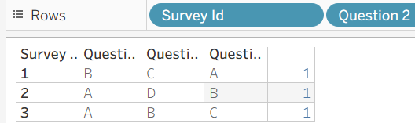
4. Develop a Tableau Dashboard
Steps
- Click New Dashboard.
- Set dashboard size to Automatic.
- Drag all three worksheets onto the dashboard.
- Arrange:
  - Top Left → Grouped Bar Chart
  - Top Right → Stacked Bar Chart
  - Bottom → Survey Table
- Enable Use as Filter on the charts for interactivity.
